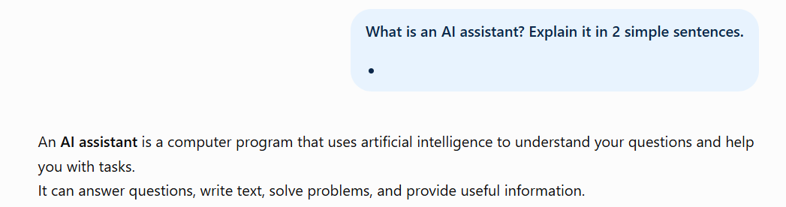
Step 1 — AI Assistant

An AI assistant is a software that uses LLM to understand what we ask and help us complete certain tasks

Step 2 — LLM
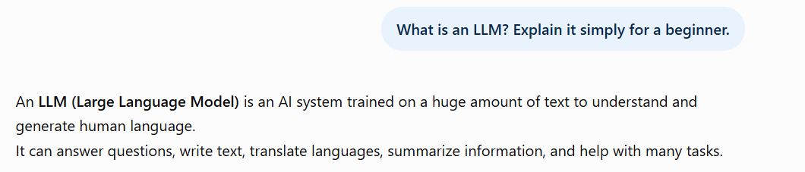
The LLM is the core of an AI assistant that helps it understand human language.

Step 3 — Hallucination
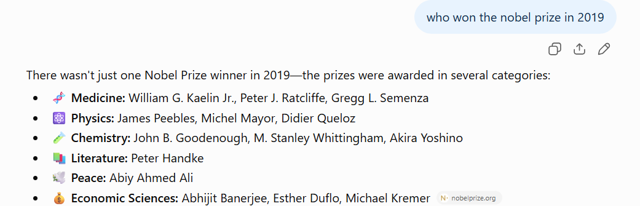
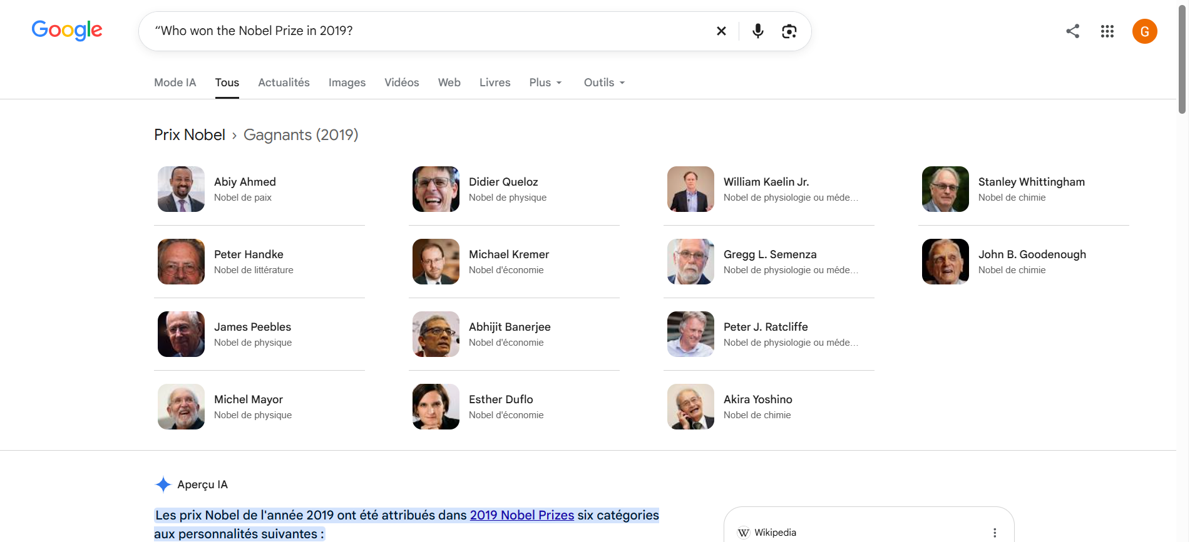

YES The info that AI gave is correct

Step 4 — Create a Good Prompt
Explain what an AI assistant is for a beginner who has never studied artificial intelligence. Use simple English, avoid technical terms, and keep the explanation under 50 words. Give the answer as one short paragraph.
• Task: Explain what an AI assistant is.
• Context: The audience is a beginner with no AI background.
• Constraints: Simple English, no technical terms, fewer than 50 words.
• Output: One short paragraph.

Step 5 — Improve a Prompt

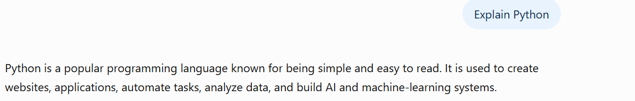
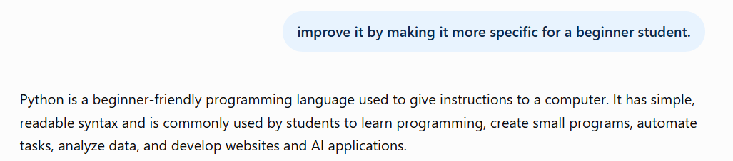

The prompt was improved by adding the Target audience and using simpler language.
Step 6 — Token & Usage Limits
*A token is a small piece of text that an AI uses to understand and process language. It can be a word, part of a word, or a symbol.
*A context window is the amount of text an AI can remember and consider at one time during a conversation.
*A token limit is how much text can be processed in one request, while a usage limit is how much you can use the AI within a certain period.

